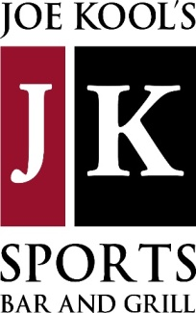

**SPECIALS**

***REUBEN EGGROLLS***

**-SERVED WITH AN ALE MUSTARD SAUCE –12.99**

***ASIAN CHICKEN SALAD***

**CRISP ROMAINE TOPPED WITH CHOPPED CHICKEN BREAST, BABY CORN, SCALLIONS, SHREDDED CARROTS, GRAPE TOMATOES, & CHOPPED PEANUTS. SERVED WITH AN ASIAN SESAME DRESSING–14.99**

***LOCO QUESADILLA***

**JUMBO FLOUR TORTILLA LOADED WITH SEASONED GROUND BEEF, REFRIED BEANS, FRESH CHOPPED JALAPENOS, TOMATOES, SCALLIONS, & A THREE CHEESE BLEND. SERVED WITH SALSA, SOUR CREAM, & GUACAMOLE -13.99**

***CHOCOLATE CHIP CAKE***

**FILLED WITH A LUCIOUS MOLTEN LAVA CENTER ACCOMPANIED WITH FRENCH VANILLA ICE CREAM & A CHOCOLATE DRIZZLE -8.99**

**\*DRINK SPECIALS\***

**$5 *PINTS OF SUMMER SHANDY***

**$6 *BACARDI MANGO CHILI W/ PINEAPPLE & TAJIN RIM***

**$9 *WOODINVILLE MANHATTAN OR OLD FASHIONED***

**$5 *BLUE SWEETARTS***

***(WHILE SUPPLIES LAST)***

**\*SUMMER DRAFTS\***

***~LEINENKUGEL’S SUMMER SHANDY***

***~BELL’S OBERON***

***~SAM ADAMS SUMMER ALE***

***~MICHELOB ULTRA***

**HAPPY HOUR-- 2 PM - 6 PM MONDAY- FRIDAY**